**ABSTRACT**

|  |  |  |  |
| --- | --- | --- | --- |
| **Title** | : |  | |
| **Researchers** | : |  |  |
|  |  |  |  |
|  |  |  |  |
| **Adviser** | : |  |  |

**(Paragraph 1 - Discussion of the System / Subsystems** – refer to the sample)

The project consists of two (2) integrated subsystems, which are, Contract and Claims Management and Collections Monitoring. The first subsystem is used to create different plans and benefits needed in a health care contract, it also used to manage contracts and claim requests of the members. The second subsystem is used to monitor payments done by the members. The system generates queries and reports such as annual sales report, payment status report, daily sales report, and weekly status report.

**(Paragraph 2 – Brief Discussion of how the project has been done** – refer to the sample)

The team was able to gather data about the project through some health care companies, health journals, thesis, internet materials and other resources. Also, the team conducted interviews to obtain further information about the business processes and rules implemented. The health maintenance organization’s coordinator and manager gave detailed explanation about the processes involved. The proponents interviewed the Sales Management head, business development group and the billing department to know the whole process of the company. Proponents prepared questions that would answer and help analyze how the whole system would process, while doing so; the group had additional questions from the interviewee’s answer for better clarification. Business rules and requirements were elaborated to the group and certain questions were asked to aid in the analysis of the business processes. Various modeling techniques were utilized in order to better understand the problems and design the most optimal solution. Fishbone diagram was made to summarize and help assess the business pains of the company. **(include also brief discussion of the methodologies used as reflected in Chapter 3)**

**(Paragraph 3 – Brief Discussion of Chapter 5)**

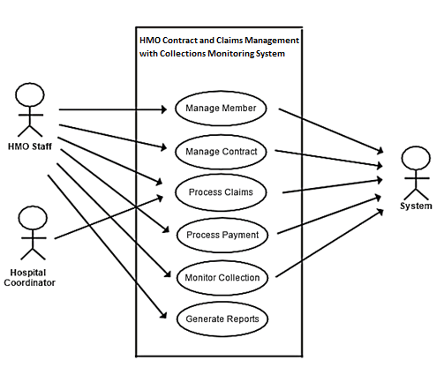 **System Use-Case:**